Ahlam Ali
Module 14 PowerBI and Creating Visualizations
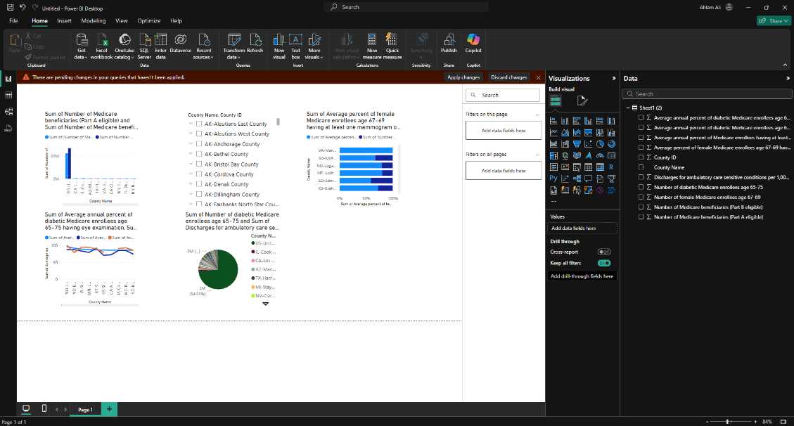
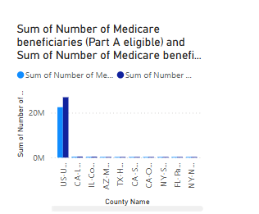
This chart helps you know how many patients Medicare are eligible from Part A versus Part B.
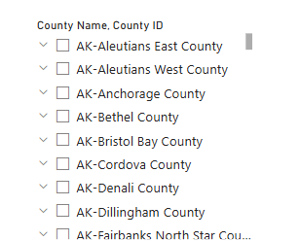
This chart helps you know the counties and the county IDs.

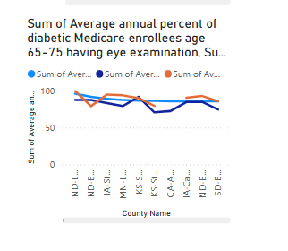
This chart helps you know which counties have the highest percentage of Medicare enrollees with at least one primary care visit in the last year.
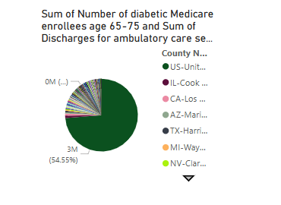
This chart represents the discharge summary percentage and the sum of diabetic Medicare enrollers.
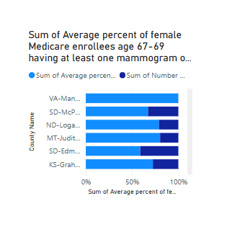
This chart represents the average female Medicare enrollees and the annual female Medicare.

